“Warfare and the Aftermath”
Bishop Calvin B. Lockett
Wednesday, February 9th, 2022

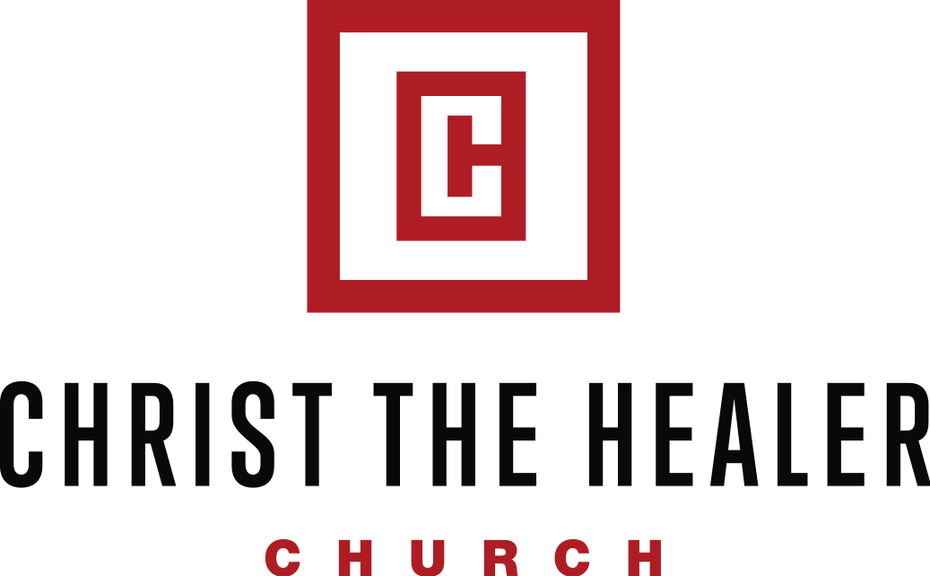

1295 Paradise Hill Rd. Clarksville, TN 37040
Office (931) 645-8785 Fax (931) 645-7643
www.cthchurch.org

“Warfare and the Aftermath”

“One of the church’s mandates is to show people who they are, what they can do, and what they have in their relationship with Jesus.” (Excerpt 2022 Vision)

“Because of Jesus’ death on the Cross and His resurrection from the dead, the forces of hell are already defeated. However, even though they have been legally stripped of their authority and power, they continue to roam around this earth, carrying out evil deeds like criminals, bandits, hooligans, and thugs. And just like criminals who refuse to submit to the law, these evil spirits will continue to operate in this world until some believer uses his God-given authority to enforce their defeat!

We need to get ahold of this truth: These demonic forces are legally stripped of their authority and are defeated! We are not puny, struggling believers who are somehow trying to learn how to cope with the devil’s attacks against us. We’re not merely trying to learn how to scrape by or survive. Jesus’ death and resurrection gave us the legal authority to keep Satan under our feet, so we must always make sure we approach spiritual warfare as victors and not victims.” (Rick Renner)

“Warfare and the Aftermath”

Colossians 2:15 interpreted: “… He gallantly strode into Heaven to celebrate His victory and the defeat of Satan and his forces. As part of His triumphal process, He flaunted the spoils seized from the hand of the enemy. Yet the greatest spectacle of all occurred when the enemy himself was openly put on display as bound, disgraced, disabled, defeated, humiliated, and stripped bare.…”

Satan has been defeated so his plot is to try to get us to defeat ourselves.

Key Point: The last thing that the devil wants us to know is the authority that we have over him.

Lesson Aim: The aim of this lesson is two-fold:

- Encourage believers that we have power to defeat and overcome the powers of darkness

- Expose the demonic opposition that believers are faced with during this season
“Warfare and the Aftermath”

A). The Soldering of Joshua

Joshua 3:10 NKJV And Joshua said, “By this you shall know that the living God is among you, and that He will without fail drive out from before you the Canaanites and the Hittites and the Hivites and the Perizzites and the Girgashites and the Amorites and the Jebusites:

Key Point: While we don’t fight these enemies that Joshua fought in the flesh, the ________of these enemies are ones that we may have to contend.

Canaanite-

“Warfare and the Aftermath”

The Canaanite spirit deals with ________and how it can betray you.

Key Point: It was the Canaanite spirit that caused Aachen to _______ money at the expense of disobeying God.

But God has a problem when you have ________ and your _________has you!

Content/Contentment-

“Warfare and the Aftermath”

Joshua 3:10 NKJV And Joshua said, “…the Canaanites and the Hittites…”

Hittite-

The Hittite spirit will bring _____________and ______ and ________________.

Israel dealt with a Hittite spirit under Moses and Joshua because she was ________to possess the land.

Fear stops you from _____________the blessings of God.

“Warfare and the Aftermath”

The Hittite spirit will try to steal your _______ and replace it with _______ and _________.

Hope-refers to ______________.

When expectations are __________, fear, dread, and terror set in.

The word Hivite means-

The Hivite spirit speaks of our conflict with the _________and its ___________.

“Warfare and the Aftermath”

The Hivite spirit will pull you outside of God’s _______ and God’s ______ for your life.

The Prodigal lived under the _________of the Hivite spirit.

2 Timothy 4:9 CEV Come to see me as soon as you can.

2 Timothy 4:10 CEV Demas loves the things of this world so much that he left me and went to Thessalonica…

Can’t

Can't is the worst word that's written or spoken;
Doing more harm here than slander and lies;
On it is many a strong spirit broken,
And with it many a good purpose dies.

It springs from the lips of the thoughtless each morning
And robs us of courage we need through the day:
It rings in our ears like a timely-sent warning
And laughs when we falter and fall by the way.

Can't is the father of feeble endeavor,
The parent of terror and half-hearted work;
It weakens the efforts of artisans clever,
And makes of the toiler an indolent shirk.

It poisons the soul of the man with a vision,
It stifles in infancy many a plan;
It greets honest toiling with open derision
And mocks at the hopes and the dreams of a man.

Can't is a word none should speak without blushing;
To utter it should be a symbol of shame;
Ambition and courage it daily is crushing;
It blights a man's purpose and shortens his aim.

Despise it with all of your hatred of error;
Refuse it the lodgment it seeks in your brain;
Arm against it as a creature of terror,
And all that you dream of you some day shall gain.

Can't is the word that is foe to ambition,
An enemy ambushed to shatter your will;
Its prey is forever the man with a mission
And bows but to courage and patience and skill.

Hate it, with hatred that's deep and undying,
For once it is welcomed 'twill break any man;
Whatever the goal you are seeking, keep trying
And answer this demon by saying: "I can.”

Never say that you can’t when God says you can.
Never say that you won’t when God says you will.
Never say that you shall not, when God says

