2022 Leaders and Ministry Workers’ Training (Session #4)
“Leadership and the Aftermath”
Wednesday, January 26th, 2022

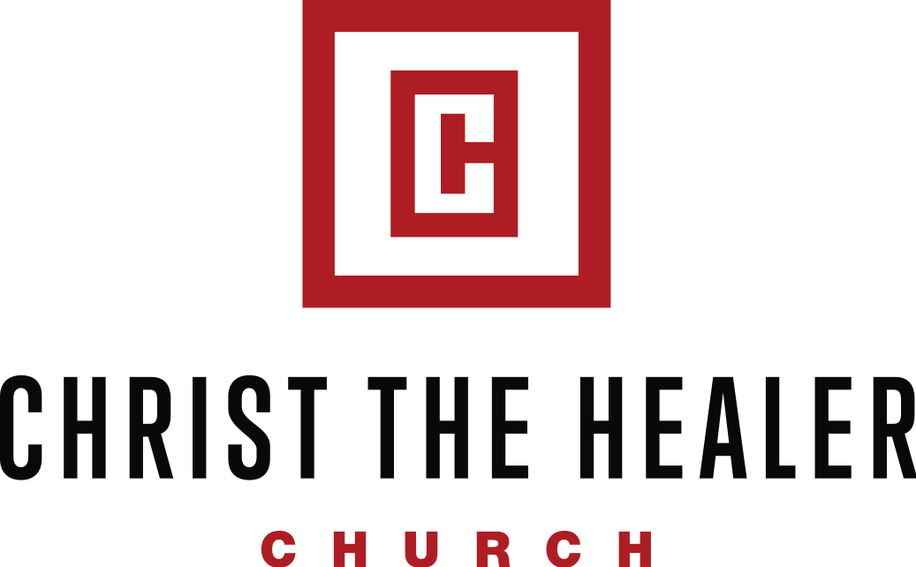

1295 Paradise Hill Rd. Clarksville, TN 37040
Office (931) 645-8785 Fax (931) 645-7643
www.cthchurch.org

2022 Leaders and Ministry Workers’ Training (Sess. #4)
“Leadership and the Aftermath”

Lesson Aim: The aim of this lesson is two-fold:

- Stress the importance of leaders and leadership—particularly during the season of the Aftermath
- Examine some of the characteristics of great leadership by looking at the life of Joshua

Key Point: If you’re saved, then in the Eyes of God, you are a leader.

John Maxwell’s definition of leadership-

Key Point: Some of the greatest leadership is displayed during what we call, “Seasons of the ___________.”

Aftermath- something that results or follows from an event, especially one of a disastrous or _____________ nature.

2022 Leaders and Ministry Workers’ Training (Sess. #4)
“Leadership and the Aftermath”

Many times we look at the principle of discipleship without considering its correlation with leadership.

Proverbs 22:1 NKJV A good name is to be chosen rather than great riches, Loving favor rather than silver and gold.

Proverbs 22:1 CEV A good reputation and respect are worth much more than silver and gold.

A). The_____________of Joshua

Joshua 1:1 NKJV Now after the death of Moses the servant of the LORD it came to pass, that the LORD spake unto Joshua the son of Nun, Moses' minister, saying, (emphasis added)

2022 Leaders and Ministry Workers’ Training (Sess. #4)
“Leadership and the Aftermath”

B). The ____________of Joshua

Amalek is a picture of our fallen ____________.

"This conflict between Israel and Amalek is a picture of the inward battle that Christians face every day. It is the battle between our flesh and the Spirit of God. Amalek means "a people that exhausts or consumes." The Amalekites are a picture of the sinful desires of our flesh that consume, destroy, and exhaust us like a person trying to free themselves from the bondage of a rope."....Beloved, our flesh will always oppose us, but need not oppress us. It will ever conflict, but need not conquer. It will constantly harass and hassle, but need not hinder or harness us because of the power of the Holy Spirit Who indwells every believer. Through the Holy Spirit we can get victory over our flesh." (Rod Mattoon)

2022 Leaders and Ministry Workers’ Training (Sess. #4)
“Leadership and the Aftermath”

“Amalek, a descendant of Esau, is a type of the flesh—that is, the evil, corrupt, Adamic nature of man. Observe the following parallels between the flesh and Amalek: (1) It presents itself after the Holy Spirit is given at conversion to fight against the Spirit; (2) The LORD will have war with the flesh from generation to generation; (3) It is never eradicated from the believer till death or the Rapture of the church.” (William MacDonald)

1). The _____________ of Amalek.

The primary battle that you’ll fight is the battle with _____________or the battle with our flesh.

2022 Leaders and Ministry Workers’ Training (Sess. #4)
“Leadership and the Aftermath”

The ____________of Amalek.

The truths about Amalek are an illustration of the spiritual attacks believers undergo from the flesh, the devil, and the world. (Adrian Rogers)

Satan and the world ______________together to arouse or get us in our flesh.

Satan has been ____________so his plot is to try to get us to defeat ______________.

1). He Attacks ______________.

2). He Attacks _______________.

2022 Leaders and Ministry Workers’ Training (Sess. #4)
“Leadership and the Aftermath”

Key Point: Satan won’t attack us at our strongest point, but at our _________because that’s when our flesh is tempted the most.

Key Point: Not only must we be aware of the fact THAT Satan will attack, but we must know ourselves well enough to sense when we’re the most vulnerable.

The ____________to Amalek.

The key to overcoming Amalek is to be ____________.

Because our battle with Amalek is a _______battle, we must exercise daily _____________.

2022 Leaders and Ministry Workers’ Training (Sess. #4)
“Leadership and the Aftermath”

Joshua, you have the potential to be a great leader, but you’re going to have to deal with Amalek!

The _____________of Joshua

Before Joshua was a great leader, he was a great ___________.

Before we become great leaders, we must be great ______________.

