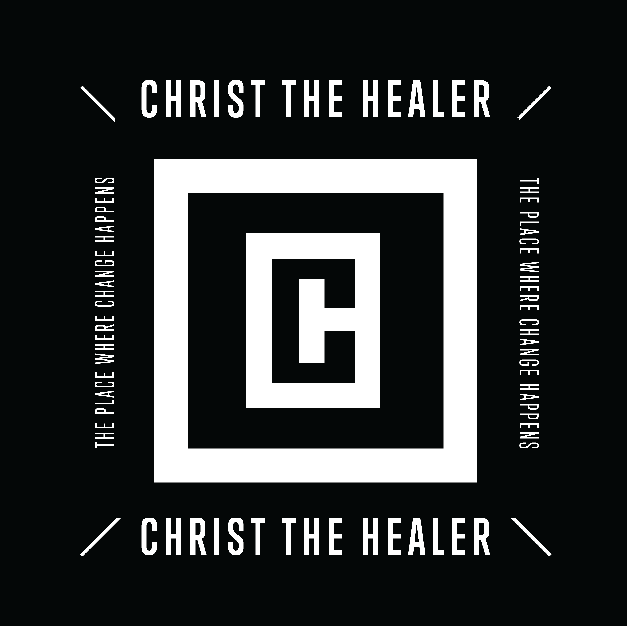

Christ The Healer Church
2022 Until…-A Season of Aftermath—Alignment, Building, Clarity
__________________________________________________________________
Vision of 2022 Until…

Christ The Healer Church Community,

I greet you in Jesus’ Mighty Name. In the book of Isaiah, God told the prophet that, '“…My thoughts are not your thoughts, Nor are your ways My ways,” says the Lord . “For as the heavens are higher than the earth, So are My ways higher than your ways, And My thoughts than your thoughts.” (Isaiah 55:8-9). While many viewed the COVID-19 pandemic as a curse, the blessing of the crisis is that it caused God’s church to seek Him for direction and guidance in every area of ministry. The past two years have brought crystal-clear clarity to a reality that the church had previously drifted away from which is, “God’s church belongs to God.” Pastors and church leaders have to depend upon God’s Voice for ideas, strategies, wisdom, and to keep The Lord’s church moving forward. During the pandemic, there were no paradigms to gather information or trends to follow from previous generations. The Lord took His church back to the place where we, “walk by faith and not by sight.” When the number of individuals infected with the COVID-19 virus were rising and in-person gatherings were discouraged, pastors and leaders couldn’t see bodies in the sanctuary and neither did we know who was still connected to our ministries and/or who’d left. In many ways, the spirit of tradition was broken as churches learned to be pliable, flexible, and open to God and to follow His Lead wherever it takes us. Those who sought God’s guidance and followed His Instructions marveled at how He kept and even increased His church and blessed His children during an unconventional time. God showed the world that He is still the Author and Finisher of our faith and is at the helm of the church that He established. Praise The Mighty Name of Jesus!!!

There are three things that we must communicate during the current season. First of all, we are to Emphasize God’s Vision. Historically, the body of Christ has overemphasized vision from a local church perspective without considering the fact that every assembly is part of God’s universal church. And while each church may be graced or anointed in a particular area--from evangelism to missions to outreach to discipleship to music and arts to youth and children’s ministry—every Christian congregation should seek to follow the Same Command(s) given by Jesus in organizing and operating His church. Jesus expressed His vision for the universal church throughout His Ministry. As a matter of fact, some of the most popular passages in Scripture—like Matthew 16:24, Luke 19:10, John 3:16—all speak about Jesus’ Passion and Heart to save the lost. The Last Words spoken by our Lord as recorded by Matthew express Jesus’ Vision for His church: “Go ye therefore, and teach all nations, baptizing them in the name of the Father, and of the Son, and of the Holy Ghost: teaching them to observe all things whatsoever I have commanded you: and, lo, I am with you alway, even unto the end of the world. Amen.” (Matthew 28:19-20, NKJV)

Several months ago, the Lord revealed to me His vision statement (our purpose statement): “To make disciples by emphasizing The Kingdom of God and The Lordship of Jesus Christ in every area of life.” An elementary way to explain Christianity to someone is, “Christianity is about the King of kings and the establishing of His kingdom.” The church of God must embrace her mission of presenting God’s Kingdom amidst a corrupt and chaotic culture. God’s Kingdom is His Comprehensive Rule over all creation. During His earthly ministry, Jesus preached, taught and demonstrated The Kingdom of God and then charged His disciples to do the same when He ascended back to glory. Our agenda will be The Kingdom Agenda—the visible demonstration of the comprehensive rule of God over every area of life. Our church will be a kingdom church—we will preach The Kingdom Message, develop kingdom families, produce kingdom marriages, raise Kingdom children, and establish God’s Kingdom throughout our community. It is our desire that, “God’s Kingdom comes and His Will be done on earth as it is in heaven.”

Secondly, our church’s assignment is to Express to God’s people their Value. The believer’s value is a multifaceted revelation that must be understood in order to advance God’s kingdom and to be effective in our callings as saints of God. One of the church’s mandates is to show people who they are, what they can do, and what they have in their relationship with Jesus. For years, the enemy has been able to cause confusion and division among us because we were ignorant of our significance. Many of the sins that have hurt and separated us—from jealousy to envy to gossiping to backbiting to coveting—had to do with our not knowing our own worth. Some of the greatest internal warfare that happens in the lives of believers centers around our inner struggles in embracing our self value. The enemy’s attacks on our value has caused our self esteem to plummet and made us question our self worth. In the past, our mental health has even been compromised and the spirits of depression and suicide have manifested because the enemy kept us blind to the revelation of our importance.

We will strive to create a value-driven culture for several reasons:

1). A revelation of our value confirms our identity. As Christians, we can boast in the fact that God is our Father and we are His children! When we got saved, we were born of God and adopted as children into His family (John 3:3, 5-6; Romans 8:14-17; 1 John 3:1-3). We were predestined by Him (Ephesians 1:5), chosen by Him (John 15:16, 1 Peter 2:9), appointed by Him (John 15:16), crucified with Him (Galatians 2:20), buried with Him (Romans 6:4, Colossians 2:12), resurrected with Him (Colossians 3:1), united with Him (1 Corinthians 6:17), clothed with Him (Galatians 3:27), complete in Him (Colossians 2:10), and shall be like Him (in form—1 John 3:2). Paul pinned in Acts 17:28—“for in Him we live and move and have our being…” (Acts 17:28 NKJV). Always remember that Jesus sent The Same Spirit that raised Him from the dead to live inside us forever! Glory to God’s High Name!

2). Our value is seen in our Authority. Christians are God’s represented authority on earth. When Jesus ascended back to heaven after completing His Assignment here on earth, He sat down in His Seat of Authority by sitting at the right hand of The Father (Hebrews 10:12). Believers sit in heavenly places in Christ (Ephesians 2:6), which means we sit in the position of His authority. As His ambassadors, we have been empowered with His authority in this sphere of existence (Luke 10:19). The fact that Jesus said that He is the light of the world (John 8:12) and believers are the light of the world (Matthew 5:14) symbolizes that His Life is to shine through us and bring light to this dark world in which we live. As citizens of God’s kingdom, we reflect and represent our King and are portraits of life in His kingdom.

3). Knowing our value provides our security. The believer’s value isn’t determined by what we do or fail to do; it’s determined because of what Jesus has done. Jesus didn’t just die for those who serve in five-fold offices according to Ephesians 4. He didn’t just die for those who preach and teach the gospel, but He died for the entire world and/or the church. And because He died for all, we are just as valuable to Him as anyone else—regardless to our titles or callings. We can be secure in knowing that once we come into relationship with Jesus, it extends throughout eternity. Our Lord Himself said, “And I give them eternal life, and they shall never perish; neither shall anyone snatch them out of My hand.” (John 10:28 NKJV)

Finally, we are to Expand/Grow the Ministry Virtually. There were paradigm shifts made during the pandemic that changed global operations and functions in all facets of society. The most obvious occurred in the virtual space. All seven mountains—arts and entertainment, business, education, family, government, media, and religion—utilized virtual platforms during times when in-person gatherings were prohibited. Ironically, organizations across all mountains found the virtual world to be an efficient, cost effective, and many times more productive means of operating. Churches were able to reach and minister to more people online than onsite as technology was utilized to carry out the Great Commission that Jesus commanded that we execute. Consequently, Christ The Healer Everywhere was birthed and we’re constantly seeking more effective ways to minister to our global church community.

An area of special emphasis is the re-launch of our Christian Education program. The Lord gave me the strategy of utilizing the digital curriculum that our church pays for monthly (Rightnow Media) as our Digital Discipleship Platform (DDP) to train and disciple our members. Jesus’ vision of discipleship is paramount in that it assimilates believers into God’s kingdom, matures them into followers of Christ, and is God’s succession plan for His church in reaching each generation until eternity. Discipleship is not a plan or a program; it’s a way of life. Thus, we will seek to disciple our members in every area of their/our lives and across all demographics—from our senior saints to our leaders to our men and our women to our marriages and our singles to our young adults and our youth. Our goal is that our members will experience harmonic wealth by being discipled in the areas of our faith, our fitness, our finances, and our families.
We will resume in-person Sunday school and children’s church on Sunday mornings as well as online Sunday school for members of our Christ the Healer Church Everywhere community beginning in February. In addition, we will roll out online Christian education classes during the week. We will continue and seek to expand our gatherings with our men’s, women’s, marriage, single’s, and young adult ministry ministries as well as the training of our elders, ministers, ministers-in-training, and deacons. We are excited to resume Youth Sundays each 4th Sunday and Young Adult Sunday each 5th Sunday.

There is both an upside and a downside to presenting virtual ministry with excellence. As stated earlier, the virtual space has afforded us the opportunity to reach and minister to a larger audience for the cause of Christ. The challenge in virtual ministry is its associated costs. . Programs, platforms, and equipment can be expensive. Currently, our media ministry is in need of more equipment. We will launch a capital campaign for the specific purpose of purchasing media equipment so that we can upgrade our current ministry platform. That seed will include finishing some work that we’ve had done on the roof and upgrading our equipment used for our Christian education ministry. I believe that the return on this Kingdom expense will be well worth the investment and shall yield the fruit of more souls being won to Christ.

Sadly, the faith of many believers was shaken during the pandemic—not just at Christ the Healer or in Clarksville—but throughout the universal body-of-Christ. Unfortunately, there were believers who like sheep, began to stray away from the sheepfold (churches) that they were part of and are scattered throughout the body of Christ. Our church was no exception as there are those that left our ministry and others that we are uncertain about because of a lack of accountability and/or response to our efforts to connect with them. Our prayer is that reclamation will occur throughout the body of Christ and those wandering will reconnect with God’s body and become actively involved in building God’s kingdom.

In closing, welcome to the year 2022–the greatest season that the church has ever seen!
---------------------------------------------------------------------------------------------------------------------
Christ the Healer Church Purpose Statement
The purpose statement of Christ the Healer Church is to make disciples of men by emphasizing The Kingdom of God and The Lordship of Jesus Christ in every area of life.

Christ the Healer Church Mission
Christ the Healer Church is a body of baptized believers whose purpose it to:
Exalt The Savior Through Worship
Equip the Believer with The Word
Edify one Another through Fellowship
Evangelize The Lord through Witnessing

Our church aspires to be Persistent in Prayer, Diligent in Discipleship, and Purposeful in our Praise.

2022 Protocols for Public Worship

Christ the Healer Church Community,

Happy New Year! I pray that all is well with you and your families and that you’ve gotten 2022 off to an amazing start. On Wednesday night, December 29th, I received a call from someone that I’d been around two days prior that he’d contracted COVID. When I got the call, my mind began racing and reminiscing on the number of individuals that I’d been around earlier that day—my family that I live with, our staff at church, two of our prayer overseers who’d worked alongside me in cutting videos for an upcoming conference in New Jersey, my in-laws who we’d accompanied (Pastor Lynn and I) to an important medical appointment, and two of the seniors in our church that are in rehabilitation facilities in our city. Although I hadn’t experienced any symptoms of the virus, I did the responsible thing in quarantining immediately and I went and got tested the next day. My rapid test came back inconclusive which means that the medical field couldn’t tell if the test were positive or negative resulting in me remaining in self-isolation until the results got back from the lab. As I am/was typing this correspondence, the nurse practitioner called and informed me that I am NEGATIVE for COVID. Glory to God’s High Name!

When I woke up this morning—January 1st, 2022— The Holy Spirit reminded me that my steps are ordered by Him and there was a Divine Purpose in my having to go through the aforementioned experience. The individual that I’d come into contact with had just gotten back from visiting family outside Clarksville and had gotten infected on vacation. The Center-of-Disease Control (CDC) had predicted that this would happen and stressed that the residents in our nation follow the recommended safety protocols (masks, social distancing, hand washing and sanitizing). The numbers are rising tremendously all around the country and Clarksville is no exception. The day before I got tested, the nurse practitioner told me that she’d seen 27 in-house positive cases from the rapid test—not including the ones that were inconclusive that she had to send out. Because of the individuals coming back to our city from traveling, the numbers could possibly rise even more.

There are many in the body that are making swift shifts in going back virtual. Some of our covenant churches in the Full Gospel Baptist Church Fellowship and others in the body have determined that they’re going virtual for the entire month of January because of the upsurge in numbers. While in prayer this morning, The Lord began to minister to me about gatherings during this season. He reminded me that I’d watched two football games yesterday—Alabama verses Cincinnati and Georgia verses Michigan—with thousands of people in attendance that were not socially distanced and the majority of them weren’t wearing masks.
I spoke with two of our members that are in the Clarksville Montgomery County School System (CMCSS) and they both verified that the school system has no plans of going virtual. When I called State Representative Jason Hodges and asked him about it, he told me that CMCSS couldn’t go virtual if they wanted because it’s mandated by the state of Tennessee that the schools in our state remain open. As I type this document, there are people who are patronizing the malls and taking advantage of the New Year’s Day sales that stores offer. Restaurants, theaters, and grocery stores are all open today with normal hours-of-operation and protocols.

In lieu of the above that the Lord showed me, I feel convicted that it’s God’s Will for Christ The Healer Church to remain open at the present time, but to use wisdom in doing so. Unlike businesses that are open eight hours each day, our corporate gatherings are roughly 7 1/2 hours each week collectively—3 hours of Manna Cafe outreach on Thursday afternoons and Saturday mornings, 2 hours of choir rehearsal between Thursday evenings and Sunday mornings, 90 minutes of worship on Sundays and an hour of teaching on Wednesday nights. There are no current prohibitions on public gatherings and we will monitor both the trends and government mandates and adjust accordingly. The Lord shared with me that the issue isn’t our being open, it’s making sure that we adhere to our protocols of operation. Our established protocols are for the safety of those that worship on our campus. Those not willing to follow our standards during this season should not attend our worship services and anyone in violation will be asked to comply. Our protocols are as follows:

Anyone who is coughing, sneezing, running a fever, displaying any types of flu-like symptoms or not feeling well should contact their health care provider and stay home

Masks are to be worn before entering our church and remain on while inside the building

A distance of six feet between those that fellowship on parking lots as well as those entering our church is highly encouraged

All our members will enter and exit from the main entrance and not utilize the doors in the fellowship hall

Disinfectant will be available in high traffic areas to include church entrances and places of fellowship

Families or individuals living under the same roof are highly encouraged to sit together if possible. Chairs will be positioned for social distancing during worship

Holy kisses, hugs, and handshakes are highly discouraged to prevent the spread of disease. Smiles, hands over hearts, and holy fist bumps are allowed

Gloves are encouraged for those serving in high traffic areas to include ushers and greeters

Those needing prayer and altar calls should be done in a manner that prohibits physical touching as well as those that unite with the church

We will exit our worship service by section to ensure that we maintain social distance while leaving the building

In closing, let’s all work together to create a safe environment to worship as we build God’s kingdom in understanding, unity, harmony, and love.

Sincerely,

Calvin B. Lockett
Senior Pastor
Christ the Healer Church

